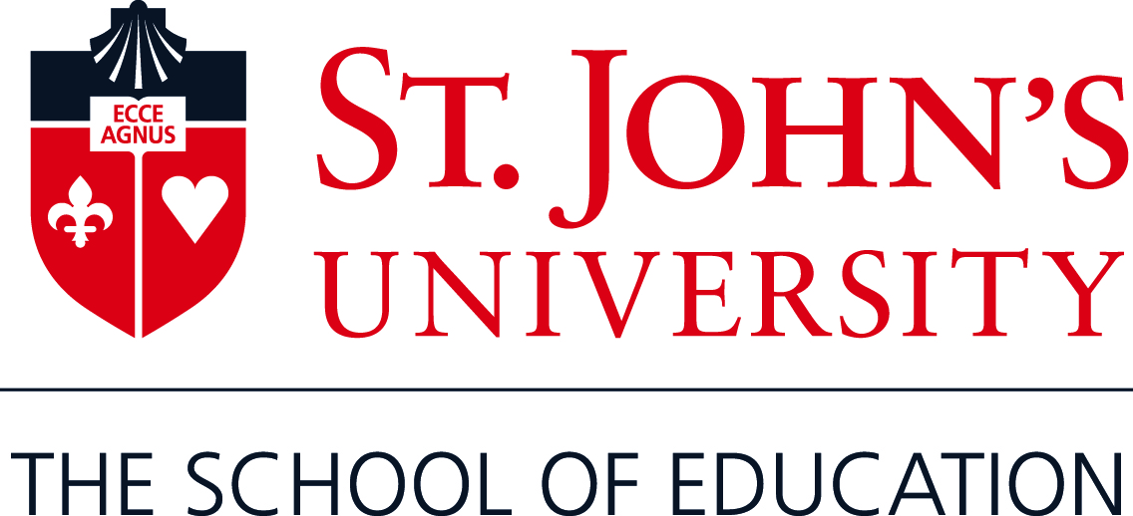

**What you need to know about satisfying DEFICIENCIES in coursework**

**(Required for Initial New York State Teaching Certification** **for Students Enrolled in Career Change and Alternative Certification Programs and for TESOL students.)**

The regulations of the New York State Education Department require universities that offer registered programs in teacher preparation (pedagogical) to ensure that students have also acquired the necessary foundation in the liberal arts and sciences before they can be initially certified to teach.

When you enroll in a Career Change or Alternative Certification (Teaching Fellow/Resident/Partner) Masters program in Education, we review your undergraduate and any other program transcripts to determine if you meet all the mandated NY State requirements. It is our obligation to inform you of specific coursework deficiencies, suggest ways to satisfy them, as well as notify you of your responsibility to complete the deficiencies and provide proof of completion to be maintained in your file. Such deficiencies can be satisfied by undergraduate or graduate coursework taken at a regionally accredited college and passed for credit.

*It is important to clarify that these deficiencies are not considered part of your teaching program requirements, will not count in your GPA, and will not appear on your transcript unless you complete them at St. John’s.* (If at any time you wish to use these credits for any other purpose, you will need to supply separate transcripts from each institution where you completed coursework.)

For all questions concerning the course requirements of your teaching program major, consult your faculty advisor. **NO CANDIDATE CAN RECEIVE UNIVERSITY ENDORSEMENT FOR NYS TEACHER CERTIFICATION BEFORE ALL DEFICIENCIES ARE SATISFIED. YOU SHOULD PLAN TO COMPLETE DEFICIENCY REQUIREMENTS PRIOR TO ALL THE COURSES IN YOUR TEACHING PROGRAM SO YOUR ENDORSEMENT WILL NOT BE DELAYED.**

Specific course requirements fall into these areas:

**General Core in Liberal Arts and Sciences**: 30 semester hours (sh) that reflect knowledge, understanding, and skills in the liberal arts and sciences. Coursework can be taken at the undergraduate or graduate level at a regionally accredited, degree-granting college and passed for credit.

* Artistic expression (3sh), *Courses in art, dance, music, or theater that provide an understanding of the art form or the ability to analyze form and content.*
* Humanities (3 sh) *Courses concerned with human thought and culture, such as literature, religion, philosophy, and cultural anthropology.*
* Concepts in history and social sciences (6sh) *Include courses in history, geography, anthropology, economics, sociology, and political science.*
* Scientific processes (6sh) *Courses in areas such as biology, chemistry, earth science or physics.*
* Mathematical processes (6sh) *Courses in mathematical reasoning, quantitative methods, number theory and concepts, algebra, analytic geometry, calculus, geometry, trigonometry, data analysis, probability, and discrete mathematics. Courses in computer science, accounting, finance, and studies in which mathematics is applied to solving problems (e.g., engineering) are not acceptable.*
* Written analysis and communication (6sh) *Acceptable courses include English composition, creative writing, and introduction to writing.*
* Language other than English (3sh) *Courses in language, or taught in another language are acceptable, including American Sign Language.*

The State requirements for courses, which must be passed with a “C” or above at the undergraduate level or “B-“ or above at the graduate level are specified in the areas below:

**Content Core**

In addition, all students must have a 30 credit Content Core. "Content core" refers to coursework that instructs candidates in the specific subject matter of the certificate title sought (e.g., Mathematics, Biology, Spanish, etc.). It is the equivalent of a major in that subject area. Course content, rather than the name of the department through which a course is offered, determines the acceptability of a course to fulfill these requirements. Courses in the methods of teaching a subject are not acceptable as study in the content area.

Courses acceptable in the content core may also be applied to the General Liberal Arts and Sciences Core.

* College coursework is study taken for college credit, completed at or transferred to a degree-granting institution of higher education approved by the New York State Commissioner of Education or a regional accrediting agency. Coursework must be offered for degree credit by the college, whether or not you obtain the degree.
* Unacceptable coursework is that which is not credit-bearing or not applicable toward a degree. Examples of unacceptable coursework: professional development courses, continuing education courses, often measured in Continuing Education Units (CEUs), audited courses, and courses that have been waived or for advanced placement (such as high school courses) without credit toward a degree.
* **CLEP exams** test your mastery of college-level material acquired in a variety of ways. You can take and pass CLEP exams in subject areas that you do not already have equivalent college credits earned. You will be allowed up to 12 credits from CLEP examinations. [College Level Examination Program (CLEP)](http://www.collegeboard.com/clep/) External Link Icon(1-800-257-9558)

**FOR TESOL STUDENTS REQUIRED TO TAKE 12 CREDITS IN A FOREIGN LANGUAGE:**

Acceptable courses are those that carry the departmental prefix for a language and may include language and literature courses. Culture, civilization, and film courses are acceptable when offered by the language department of an accredited university as part of a concentration in that language and because they are taught in that language and require a level of competence in that language.

CLEP and NYU Foreign Language Proficiency exams are acceptable for credit towards a language other than English.

*Unacceptable courses are continuing education or professional development courses issued from a non-accredited agency. Any course completion from an agency that does not furnish an official transcript indicating a grade higher than a D and completed semester hours will not be counted.*

For questions and to assist you in selecting acceptable courses to take to meet your deficiencies, it is strongly recommended that you speak with one of the following people prior to registering for any coursework:

**Dr. Kelly Ronayne**, 5th Floor Sullivan Hall, Queens Campus (718) 990-2303

**Dr. Robert Brasco**, Alternative Certification Programs Only, 5th Floor Sullivan Hall, Queens Campus (718) 990-5817

**Dr. Regina Mistretta,** Staten Island Campus, (718) 390-4491

The New York State Education Department website provides additional information about certification deficiencies here <http://www.highered.nysed.gov/tcert/faqcw.html#one>

For questions about registration and the course requirements of your teaching program major, consult your faculty advisor.