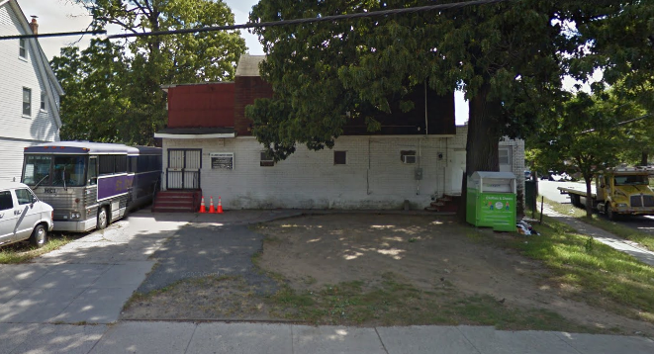
House of Completion/
St. John’s Baptist

Eartha Lee Jones Food Pantry
112-07 Guy R. Brewer Blvd
Jamaica, NY 11433
(Corner of Mathias Ave & Guy R. Brewer Blvd)

For this site please sign up on GivePulse to schedule your service.

Agency Contact
Ms. Lula Wolfe
Wolfelula@gmail.com
*(Do not contact directly, schedule through the Office of AS-L)

Nature and Purpose of Agency
The food pantry distributes food to low income community members once a week.

Tasks Available for Students
Assist with packing, moving and distributing food.

Time Requirements
Flexible. 3-4 student volunteers are needed each Thursday from 10:00 a.m.-3:00 p.m.

Student Awareness/Special Instructions
***Students should go in pairs or small groups.***

Agency Directions
Public Transportation
Take the Q30 bus toward Jamaica. Get off the bus at Jamaica Ave and Parsons Blvd. Walk 1 block south to Parsons Blvd and Archer Ave. Transfer to the Q111 bus going toward Springfield Gardens/Guy R. Brewer Blvd. Get off the bus at Guy R. Brewer Blvd. and Claude Ave.; walk one block further, and the church is on the left. (30-40 mins. by bus)

Driving Directions
Take Utopia Parkway going west. It will turn into Homelawn Street. Continue on Homelawn, and then take a right onto Hillside Ave. Turn left at Parsons Blvd, and left again at Jamaica Avenue. Turn right onto Guy R. Brewer Blvd. The church is on the left; look for the purple bus. (about 15-20 mins. from campus)

NC 03/16/18 SB

