How to Enroll in Live Sessions:
- Once you are registered and logged into APHA, go to My Training and click on the IMMUNIZATION DELIVERY LIVE SESSION DETAILS
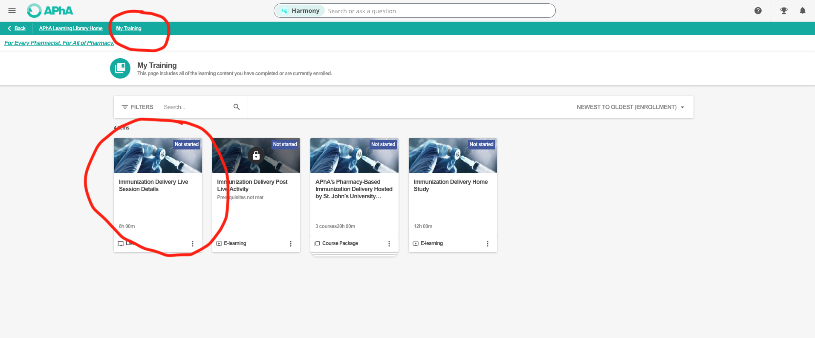

- Click on the Live session and select the appropriate session. For CPP 3203 students, choose: “Immunization CPP 3203_2026”
