Register for HR Training

- Log into Sign-On Portal and click > New UIS Experience.

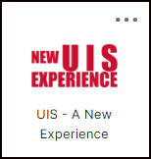

Employees should have the “Employee Resources” card on their dashboard.
(If you do not see it, you can add it through discovery by clicking on the blue “Discover More” button at the bottom of the page. )
- Mark to bookmark the card to see it on the dashboard.
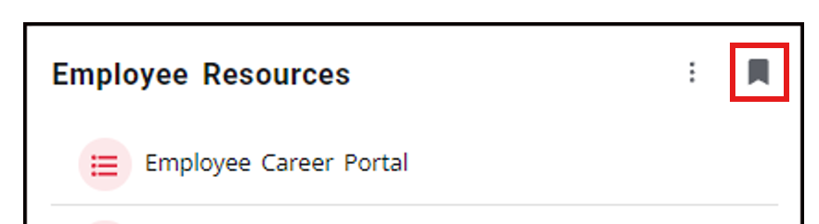

- Locate the Employee Resources card and click > Register for HR Training.

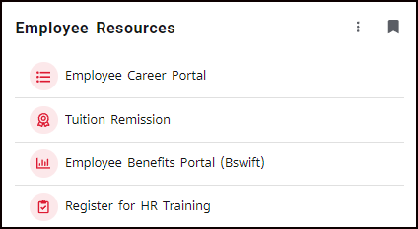

- Once the Events page opens up, you MUST click Guest Sign In from the upper right corner to authenticate.

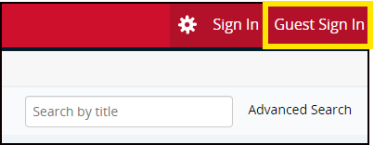

- Scroll down to view upcoming events. Note: “Restricted” means that you must be a St. John’s Faculty, Administrator, or Staff to register.

- Click on the Event Title (in Bold) to register for the event.

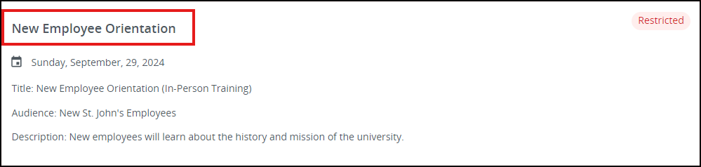

- Click on the blue Register button.

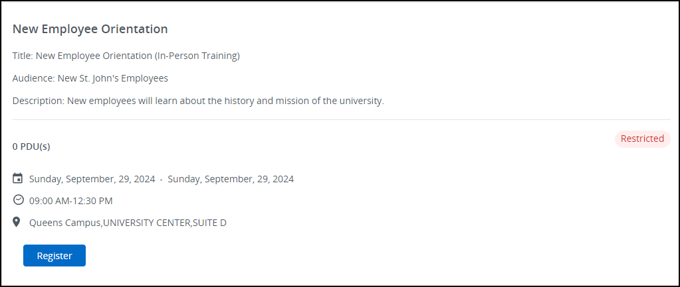

- Click the Register button again.
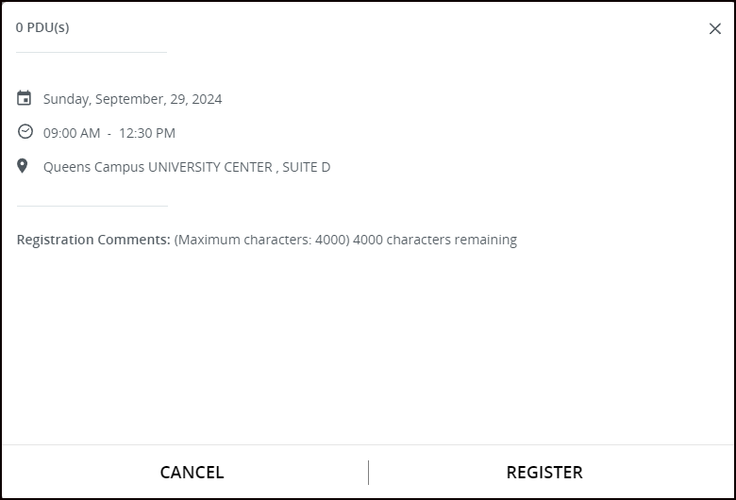

- See events you are registered for under My Events on the right.

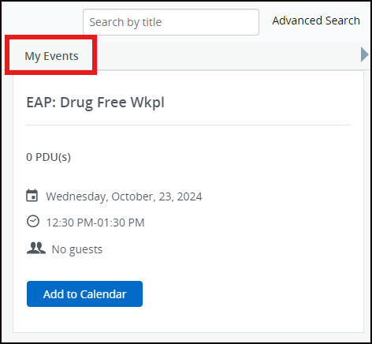

- Optional: Click > Add to Calendar once you have successfully completed registration. Click on downloaded calendar.ics file and save.

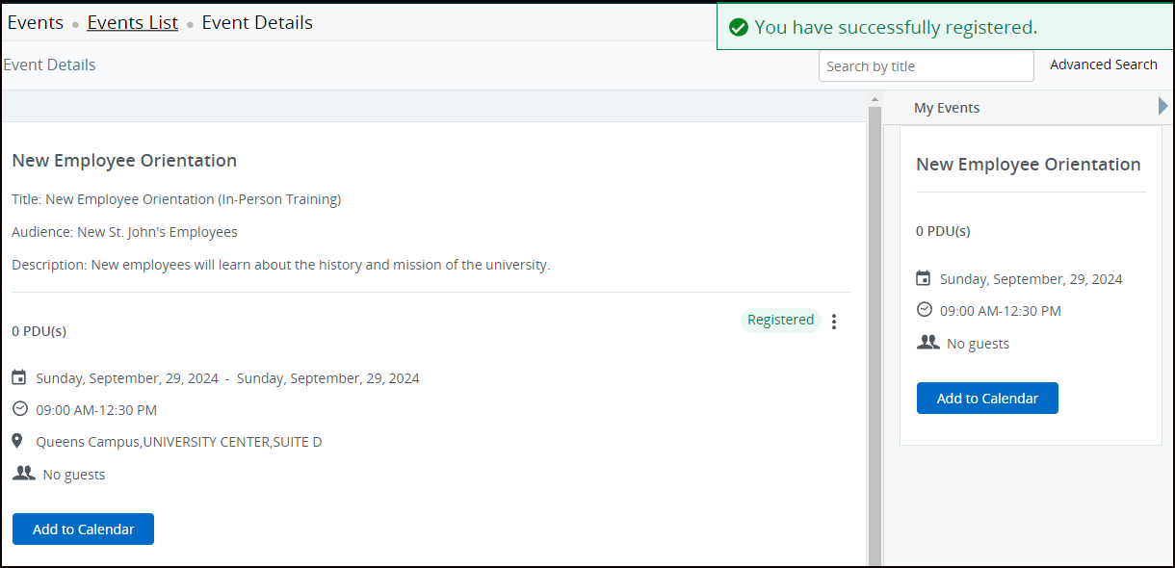

Note: For virtual events, the invitation link to the virtual session will be sent from Training & Development the night before, when registration closes.

- To cancel a registration, first select the event under My Events. This will open the event on the main screen. Then click on the ellipsis button and hit Cancel.
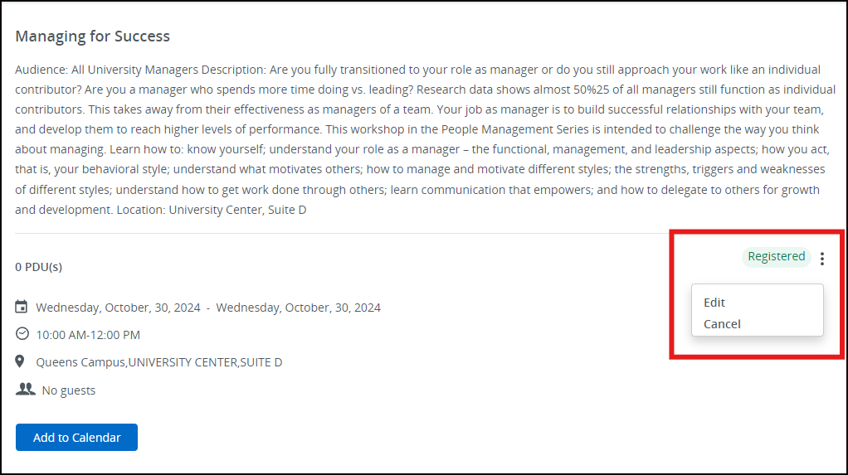

- A pop-up screen will appear. Click YES to cancel.

