
Wellness Resources for St. John’s Law Students

St. John's Law
Clinical Social Worker

Click on headings for individual websites.

Tanya Weekes, LMSW, SIFI Clinical Social Worker
718-990-6623
weekest@stjohns.edu Room: 1-19

SJU Center for Counseling and Consultation
SJU Office of Student Health Services
SJU Office of Disability Services

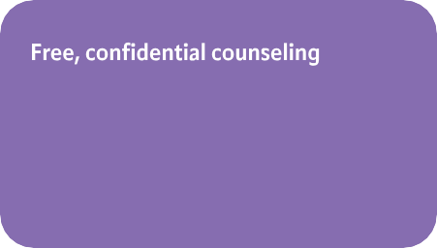

for all students

Call: 718-990-6384
(after business hours: 718-990-6352)

Schedule telehealth medical appointment online

For non-emergency health questions: 718-990-6360 (option 4)

For accommodation inquiries

Call: 718-990-6867 or
email disabilityservices@stjohns.edu

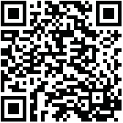
NYC Well Crisis Text Line

NYC Well offers free, confidential mental health support, including suicide prevention and crisis counsel- ing, peer support and short-term counseling via telephone, text, and web; and assistance scheduling appointments for accessing other mental health services

Text “WELL” to 65173 1-888-692-9355

Lawyer Assistance Programs

Crisis Text Line serves anyone in any type of crisis, providing access to free, 24/7 support and information via text to a trained Crisis Counselor.
Anonymous free crisis counseling
Text “HOME” to 741741
New York State New York City

The New York State and New York City Lawyer Assistance Programs (LAPs) offer free, confidential counseling for law students and family members who are affected by substance abuse, stress, depression, or other mental health issues.

New York State LAP
Confidential helpline: 877-772-8835

New York City LAP
Confidential 24/7 helpline: 212-302-5787
Thriving Campus

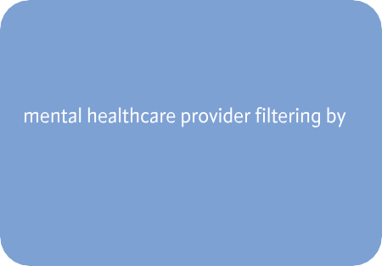
Safe Horizon

Safe Horizon's mission is to provide support, prevent violence and promote justice for victims of crime and abuse, their families and communities.

1-800-621-HOPE

Partnership with St. John’s University

Students can search for an off-campus

criteria, such as map-based location, practice areas, availability of telehealth appointments, and insurance plan coverage.

