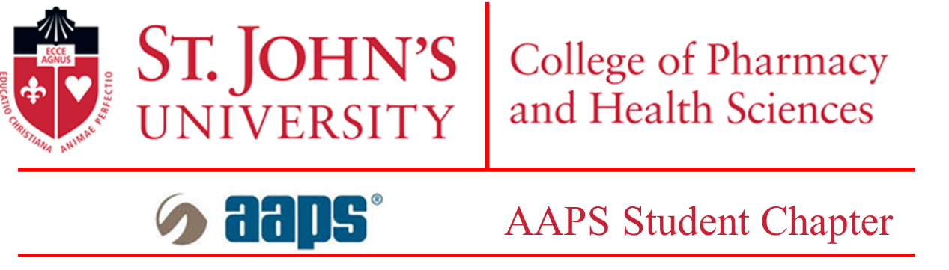

Three-Minute Thesis (3MT) Competition

Graduate students, take note: The 3MT is an exciting annual competition for you to showcase your communication skills and present your research to a general audience. It helps you condense your data and focus on the important aspects of your research.
Please submit this form as a single file by March 21 to Nitesh K. Kunda, Ph.D., Assistant Professor, Department of Pharmaceutical Sciences, at kundan@stjohns.edu.
The abstract has a limit of 300 words. The file should be saved as a .pdf file with your full name as the file name (e.g., John Doe.pdf). There is a section to write your abstract and title. Please fill in the necessary details in this document.
Applicant Details

Student Name:
Program of study (Please mark one): M.S.: ☐ Ph.D.: ☐
Major:
St. John’s email address:
Telephone number: +1 ( )-( )-( )
Semester of comprehensive exam completion (Please include the year) (Ph.D. only):
Year and semester of enrollment (M.S. only):
Title of thesis

Abstract (not more than 300 words):

Please read the following and sign:

The 3MT competition will be held on April 1, 2022, in person in room 128 of the D’Angelo Center on the Queens, NY, campus of St. John’s University. I have informed my mentor of my intention to apply to compete in the 3MT. I understand that the 3MT committee will notify me of my selection and provide me with the guidelines and judging criteria.
X___________________
Student’s Signature
I fully support my mentee’s application.
X_________________
Mentor’s Signature

